**KadiMACCABIAH**

**RELAY RACES!**

**Cost: $12 includes all activities, T- Shirt and snacks**

There will be a place for Parents to sit and shmooze during event!

**TO REGISTER, CONTACT YOUR LOCAL YOUTH DIRECTOR/ADVISOR**

**Chapter Registration is due: Monday, October 22, 2014**

For more information, contact seth@nerusy.org / 617-699-6131

AS PER REGIONAL POLICY – NO REFUNDS!





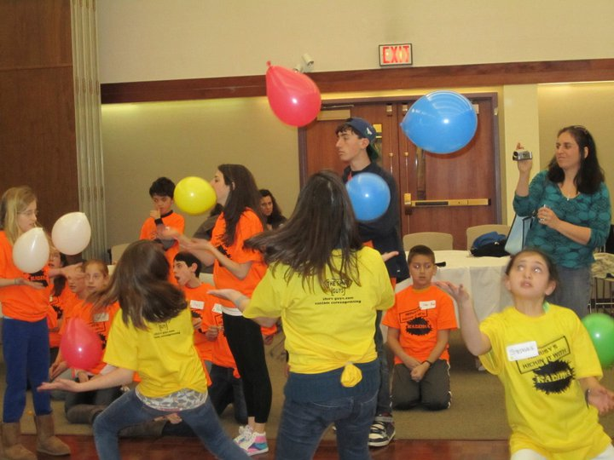

**MAKE YOUR OWN SUNDAE!**

**COLOR WAR!**

**FUN GAMES!**

**Exclusively for NERUSY’S South Shore Chapters!**

**Grades 3 to 5!**

**Sunday, October 26th**

**2 Cheshvan 5775**

**2:00pm to 3:30pm**

**Temple Emanu-El in Providence, RI**

NERUSY’S