JUNIOR USY
& PROZDOR’S
New England Region
BATTLE OF THE SEXES
Sunday, March 17, 2013
6 Nisan 5773
Hebrew College
160 Herrick Road
Newton Centre, MA
2:00-4:30 PM
Cost: $15.00

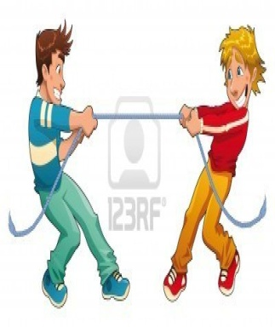
Dairy Lunch Included
Silly Games & Fun Competitions

wear RED 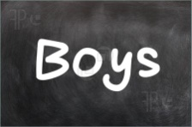 wear BLACK
______________________________________________________________________________
Deadline: Chapter registration form must be RECEIVED in the
NERUSY office by Wednesday, March 6, 2013.

One check per chapter made out to NERUSY.
Every participant must be a paid Junior USYer.

As per regional Youth Commission policy, there are no refunds.
Questions? Contact Miriam Iken at miriam@nerusy.org / 617-964-8210

